The Gender Mainstreaming Approach and Integration

Gender sensitivity is a long-term process that needs extensive efforts to be fully understood and implemented at all levels of any organization. We can however say confidently that acceptance was reached by all partners at the management level and most importantly at the staff level. Implementing partner to FPU, Synergy-Takamol, worked closely with partners in the region to develop policies and just systems of operation in an ethical, culturally sensitive, and professional way. The goal of coaching is that gender is mainstreamed into all related documents such as procedures manual, bylaws, editorial handbook, and activities such as workshops and forums, and most importantly gender is mainstreamed into service delivery (media production).

¨By women for women means that the content produced takes into account women data, interests, and outcomes.¨

Throughout the five years of the programme, the interventions were tailor made to each organization and the goal of the exercise was to coach and shadow each of them to generate their institutional Gender Policy. Then the goal was for media outlets to make the bridge to start building their gender editorial policy based on balanced reporting away from gender stereotyping, as well as giving a voice to women in leadership positions. In the end, gender justice is reached by ensuring balanced reporting, fighting stereotypes and empowering women in the media.

The evolution of gender mainstreaming occurred through the years:
- In Y1 and Y2 we achieved gender concept sensitization, gender justice sensitization, in principle acceptance of the importance of gender justice within the media sector. Gender policies were generated.
- In Y3 acceptance of the importance of gender justice within the media sector was confirmed. Gender policies implemented and updated. There was an expansion of gender justice in editorial practices.
- In Y4, advocacy, coaching, and capacity building were implemented in a tailored way for partners.
- Y5, the focus was on sustainability and coordinating a gender core group to act as a form of gender accountability or ombudsman in the Syrian media sector.

Methodology and Monitoring
Our methodology (as outlined in the visual) consists of accessible and tailored coaching, training and shadowing. The integration started from a presentation/explanation/example based application on gender concepts and mainstreaming within the life of the organization and the cycle of all projects and enterprises. For example, after FPU and Synergy-Takamol coaches would present learning sessions on gender, stereotyping and the like to partners, then the partners would have a bridging day used to review previously presented material giving examples about how unconscious stereotyping is prevalent in our region. The practice then moved to examples on how to apply tools aimed at avoiding stereotyping and promoting gender justice. The result by the end of lively sessions, in which management and editorial teams participated actively, was that a draft of a gender policy was generated. It includes detailed processes in law, mainstreaming systems, and editorial main points. The relevant points are developed into policies to form the gender policy. It was very important to reach the ultimate aim where the policies translate into systems and specific processes that are relevant to the media organisation´s mission and activities, and most importantly that it came from honest conviction rather than ease of matter.
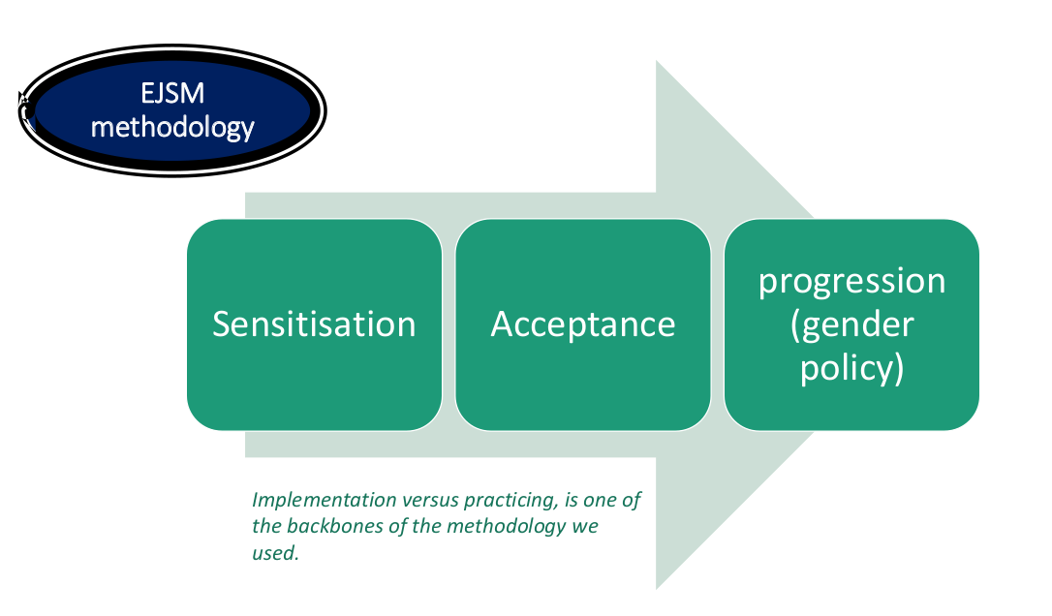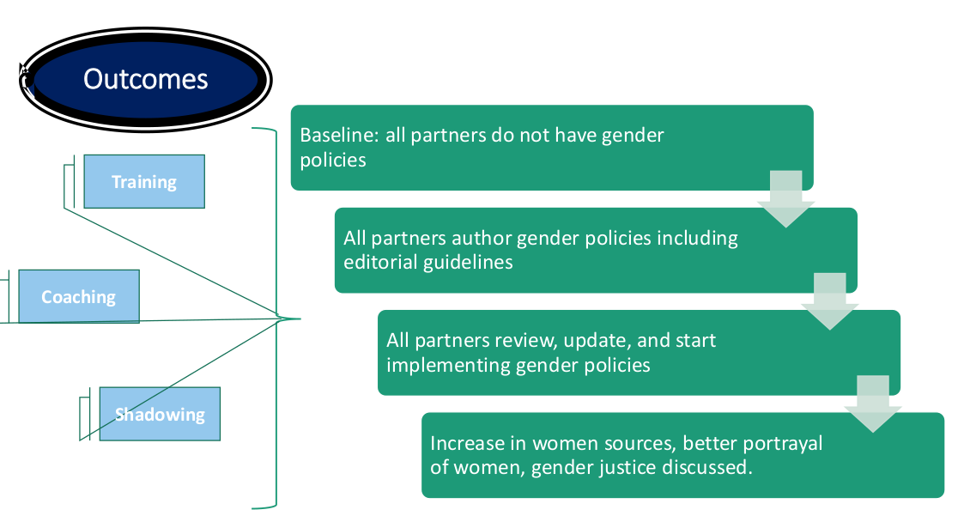
Monitoring is a fundamental element to measure how and to what depth gender and inclusivity is taken into account for an organisation's function and holistic approach. Gender audits were performed yearly to assess baseline data and progress for gender activities. Progress markers have been developed to indicate change, and baselines were taken when organisations first partnered with FPU and have been assessed on these indicators and outcomes yearly. The progress markers are listed below:
- Gender policy is endorsed and implemented
- Improved working conditions that respond to women’s and men’s needs (more inclusive workplace)
- More inclusive decision making (on incremental scale) - Increased presence of women in managerial and decision-making positions (quantitative assessment)
- Gender mainstreaming is ensured in training and professionalisation of its own staff (or toward its members)
- Promoting gender justice in service delivery or content production- Media outlets have improved editorial policy that promotes gender justice which is reflected in its media content productions

Achievements

- Gender sustainability: Tailor- made to each partner to provide them with human resources and tools to implement gender sensitization and gender justice implementation understanding to new staff to maintain sustainability beyond the programme and gender experts’ support. The process will be integrated within the human resources induction procedures. Each partner was asked to assign 2 persons at least to take part of the programme, one woman and one man in an effort of inclusivity to empower men to be gender justice Champions.
- Giving women a voice: Implemented through the formation of a core group that will be the vehicle of work. The core group is being trained and then shadowed to launch projects or activities and is led and initiated by committed women and men to implement ideas and projects that are beneficial to the media sector as a whole for gender justice.
- Women in the media: Features, actions, content produced and published by women for women. This is done through cooperation and across several media outlets which would provide a space for cooperation and the involvement of make champions in the process.
- Women in dialogue: The dialogue space will be constructed around Syrian female journalists identified as having the necessary basic qualification to provide direction and leadership of sorts. The facilitation provided by experts will help filter the topics and actions.

